Journal of Applied and Computational Sciences 1 (2026) 1-15
Contents lists available at ………………
Journal of Applied & Computational Scienceses
journal homepage: jacs.baghlan.edu.af

Article title: Maximum 20 words, in Times New Roman Font, size 14, bold, left-aligned, and written in sentence case.

Author^{🖂1}, Author², Times New Roman Font Size 12, Sentence Case

Affiliation¹, City/Province, Country, Times New Roman Size 8, Sentence Case
Affiliation², City/Province, Country, Times New Roman 8, Sentence Case
🖂E-mail: author email address (corresponding author)

ARTICL EINFO |  | ABSTRACT
Article history:  Received:  Revised:  Accepted: |  | Abstract is the most important part and, in fact, the mirror of the article. The abstract should be written in a way that accurately reflects the content of the article. The maximum word count of the abstract is 250 words. The abstract should present and introduce the topic, research objective, research method and data, and the results obtained from the study. Since the abstract is of special importance and its word count is limited, careful attention must be paid in the choice of words.  ©2026 Bughlan Unvercity. All rights reserved
Keywords:
First keyword; Second keyword; Third keyword; Fourth keyword; Fifth keyword;
Sixth keyword
- Introduction
The introduction of the article contains the problem, research objective, necessity and significance of the study, the main research question, materials and methods (sampling methods, data collection tools, data analysis methods, and research location), findings/results, and conclusion. The introduction starts with general concepts and concludes with specific details. The purpose of writing it is to enable the evaluator to fully understand the necessity and importance of conducting the proposed research.
To cite this article: Last name, First name. (Year). Article title. ……. Journal of Applied and Computational Sciences , Vol. 1, Issue. 1, Serial No. 1- Spring (2026), 1-14. License: RCTD – GNJR – 0018 - 23. Publisher: University of Baghlan
In fact, the introduction is a general explanation about the content of a scientific-research work, written with a general-to-specific approach to clarify the idea of the topic for readers and explain why this research is being conducted. Unlike the abstract, the introduction is not restricted or limited in word count.
The article text should be prepared using Microsoft Word. The font of the text should be Times New Roman, size 12, with right and left margins of 2.8 cm, a bottom margin of 3 cm, and a top margin of 2 cm. Line spacing should be 1.15. The length of the article should be approximately 5,000 to 8,000 words (excluding the abstract, references, and appendices, if any). Authors are expected to write the article carefully and thoroughly review and revise it before submission.
For managing references and citations, it is recommended to use software such as Zotero or Mendeley, and the citation style for social sciences disciplines (APA) can be applied. For example:

Example paragraph (with APA citations)
Recent developments in educational technology have significantly influenced teaching and learning processes in higher education. Researchers have shown that the integration of digital tools can improve students’ engagement, critical thinking, and collaborative learning (Johnson, Adams Becker, Estrada, & Freeman, 2015). In particular, online learning platforms and digital resources provide flexible learning environments that allow students to access educational materials anytime and anywhere (Anderson, 2017). However, despite the growing use of technology in education, several studies indicate that many institutions still face challenges related to infrastructure, digital literacy, and effective pedagogical integration (Selwyn, 2016). Therefore, further research is needed to examine how technological tools can be implemented more effectively in order to enhance students’ learning outcomes and overall educational experiences.

The reference style for natural sciences, the Vancouver method, can also be used. For example:

Example paragraph (with Vancouver citations)
Cardiovascular disease remains the leading cause of death worldwide, accounting for nearly 18 million deaths annually [1]. Recent research highlights that lifestyle modifications such as diet and exercise can significantly reduce risk [2,3]. Moreover, advances in medical technology have improved early detection and treatment outcomes [4].
For more information on referencing, refer to the “Brief Guidelines for Writing an International Journal Article, Baghlan University.”
Additionally, the article text must be carefully checked for spelling and grammatical errors. Using software such as Grammarly for editorial review is also recommended.
In the introduction section, the main objective of the article should be clearly stated. This section includes a review of related studies and research, as well as a statement of the research objective in continuous text. The introduction should reference important sources and studies in the field and clarify the significance and role of the present research. This section should be written in cohesive paragraphs, not in a list format.
Authors should provide an appropriate background and literature review to introduce existing methods and solutions, highlight the best achievements of previous research, indicate the main limitations of prior studies, and explain the research objectives aimed at addressing these limitations. In addition, the novelty and scientific value of the research should also be specified. Long reviews or summarizing results should be avoided in this section. The literature review should not introduce each author separately; instead, articles should be grouped based on similar methods or topics and reference a set of related sources.
At the end of the introduction, authors should clearly state the existing research gaps and demonstrate the innovation of the study. Research questions, objectives, and the scientific contribution of the study should also be mentioned. For example, one could write:
“Few researchers have addressed the topic of …… . Additionally, limited studies have been conducted on ……. Therefore, the present study aims to examine ……. The objectives of this research are ……. This study has been conducted with the purpose of ……. ”
This section is considered the introduction of the article. In general, the structure of an article includes the following sections: title, author(s) name(s) with organizational affiliation and email of the corresponding author, abstract, keywords, introduction, research method, findings and discussion, conclusion, acknowledgments, references, and appendices if necessary. Therefore, the article should clearly explain the background of the topic, the work carried out by the author, the method used, the results obtained, and finally the significance and implications of the research. Overall, the introduction usually constitutes about 15 to 20 percent of the total article length and presents the topic background, research significance, and study objectives.

- Method Research
The research method refers to the activities carried out by the researcher to achieve the results. The researcher must explain the method and materials of the study. These activities include the entire research process, from the beginning to the completion of the study. The research method should be written in accordance with scientific literature and by the researcher themselves. If specific algorithms or methods are used in the study, they should be explained in detail. Additionally, the process of data collection and acquisition should also be described clearly and comprehensively.
The type, quality, and sources of the data should be described in detail. If various variables are used in the research, each variable should be explained separately, and their potential role in the study should be noted. If necessary, the researcher can present the data in one or more tables for better clarity.
Previously published methods should be cited with appropriate references, and only relevant modifications should be explained. Avoid repeating the details of well-known and established methods. The methods section can be presented as a single integrated section or divided into subsections. All content in this section should be written in paragraphs. The length of this section should be approximately 10 to 15 percent of the total article.
- Results / Findings
In this section, the research findings are analyzed using standard methods and tools. Including tables and graphs in this section is common. The Findings and Discussion section presents the results obtained from data analysis and explains these results in relation to the research questions. Additionally, in this section, the results are interpreted and analyzed in the context of relevant theories and scientific sources related to the research topic. The Findings and Discussion section is the largest part of the article, usually comprising about 40 to 60 percent of the total article. In this section, the results of data analysis are presented and compared with previous studies. It is necessary to clearly highlight the differences and similarities between the findings of the present research and the results of prior studies.
It is recommended that the Findings and Discussion section be organized into clearly defined subsections so that the explanation of the findings is presented with greater clarity and precision. The content of this section should be objective, accurate, and data-based, avoiding personal opinions. Numbers, tables, and figures such as charts and graphs can be used to better display the results. All tables and figures should be numbered according to their order in the text; for example: Table 1, Table 2, Table 3, and Figure 1, Figure 2, Figure 3, and so on.

Table 1. An example of a table (font size 10 pt)
An example of a heading | Column A | Column B
Add an entry | Row 1 | Row 1
Add an entry | Row 2 | Row 2
Add an entry | Row 3 | Row 3

Table titles should be placed above the table, and figure titles should be placed below the figure. These titles should be written in Times New Roman, font size 10, and centered.

Fig. 1. An example of a figure (font size 10 pt)
Tables and figures, such as Table 1, Table 2, Table 3, Fig. 1, Fig. 2, Fig. 3, etc., should be presented with complete and clear explanations.
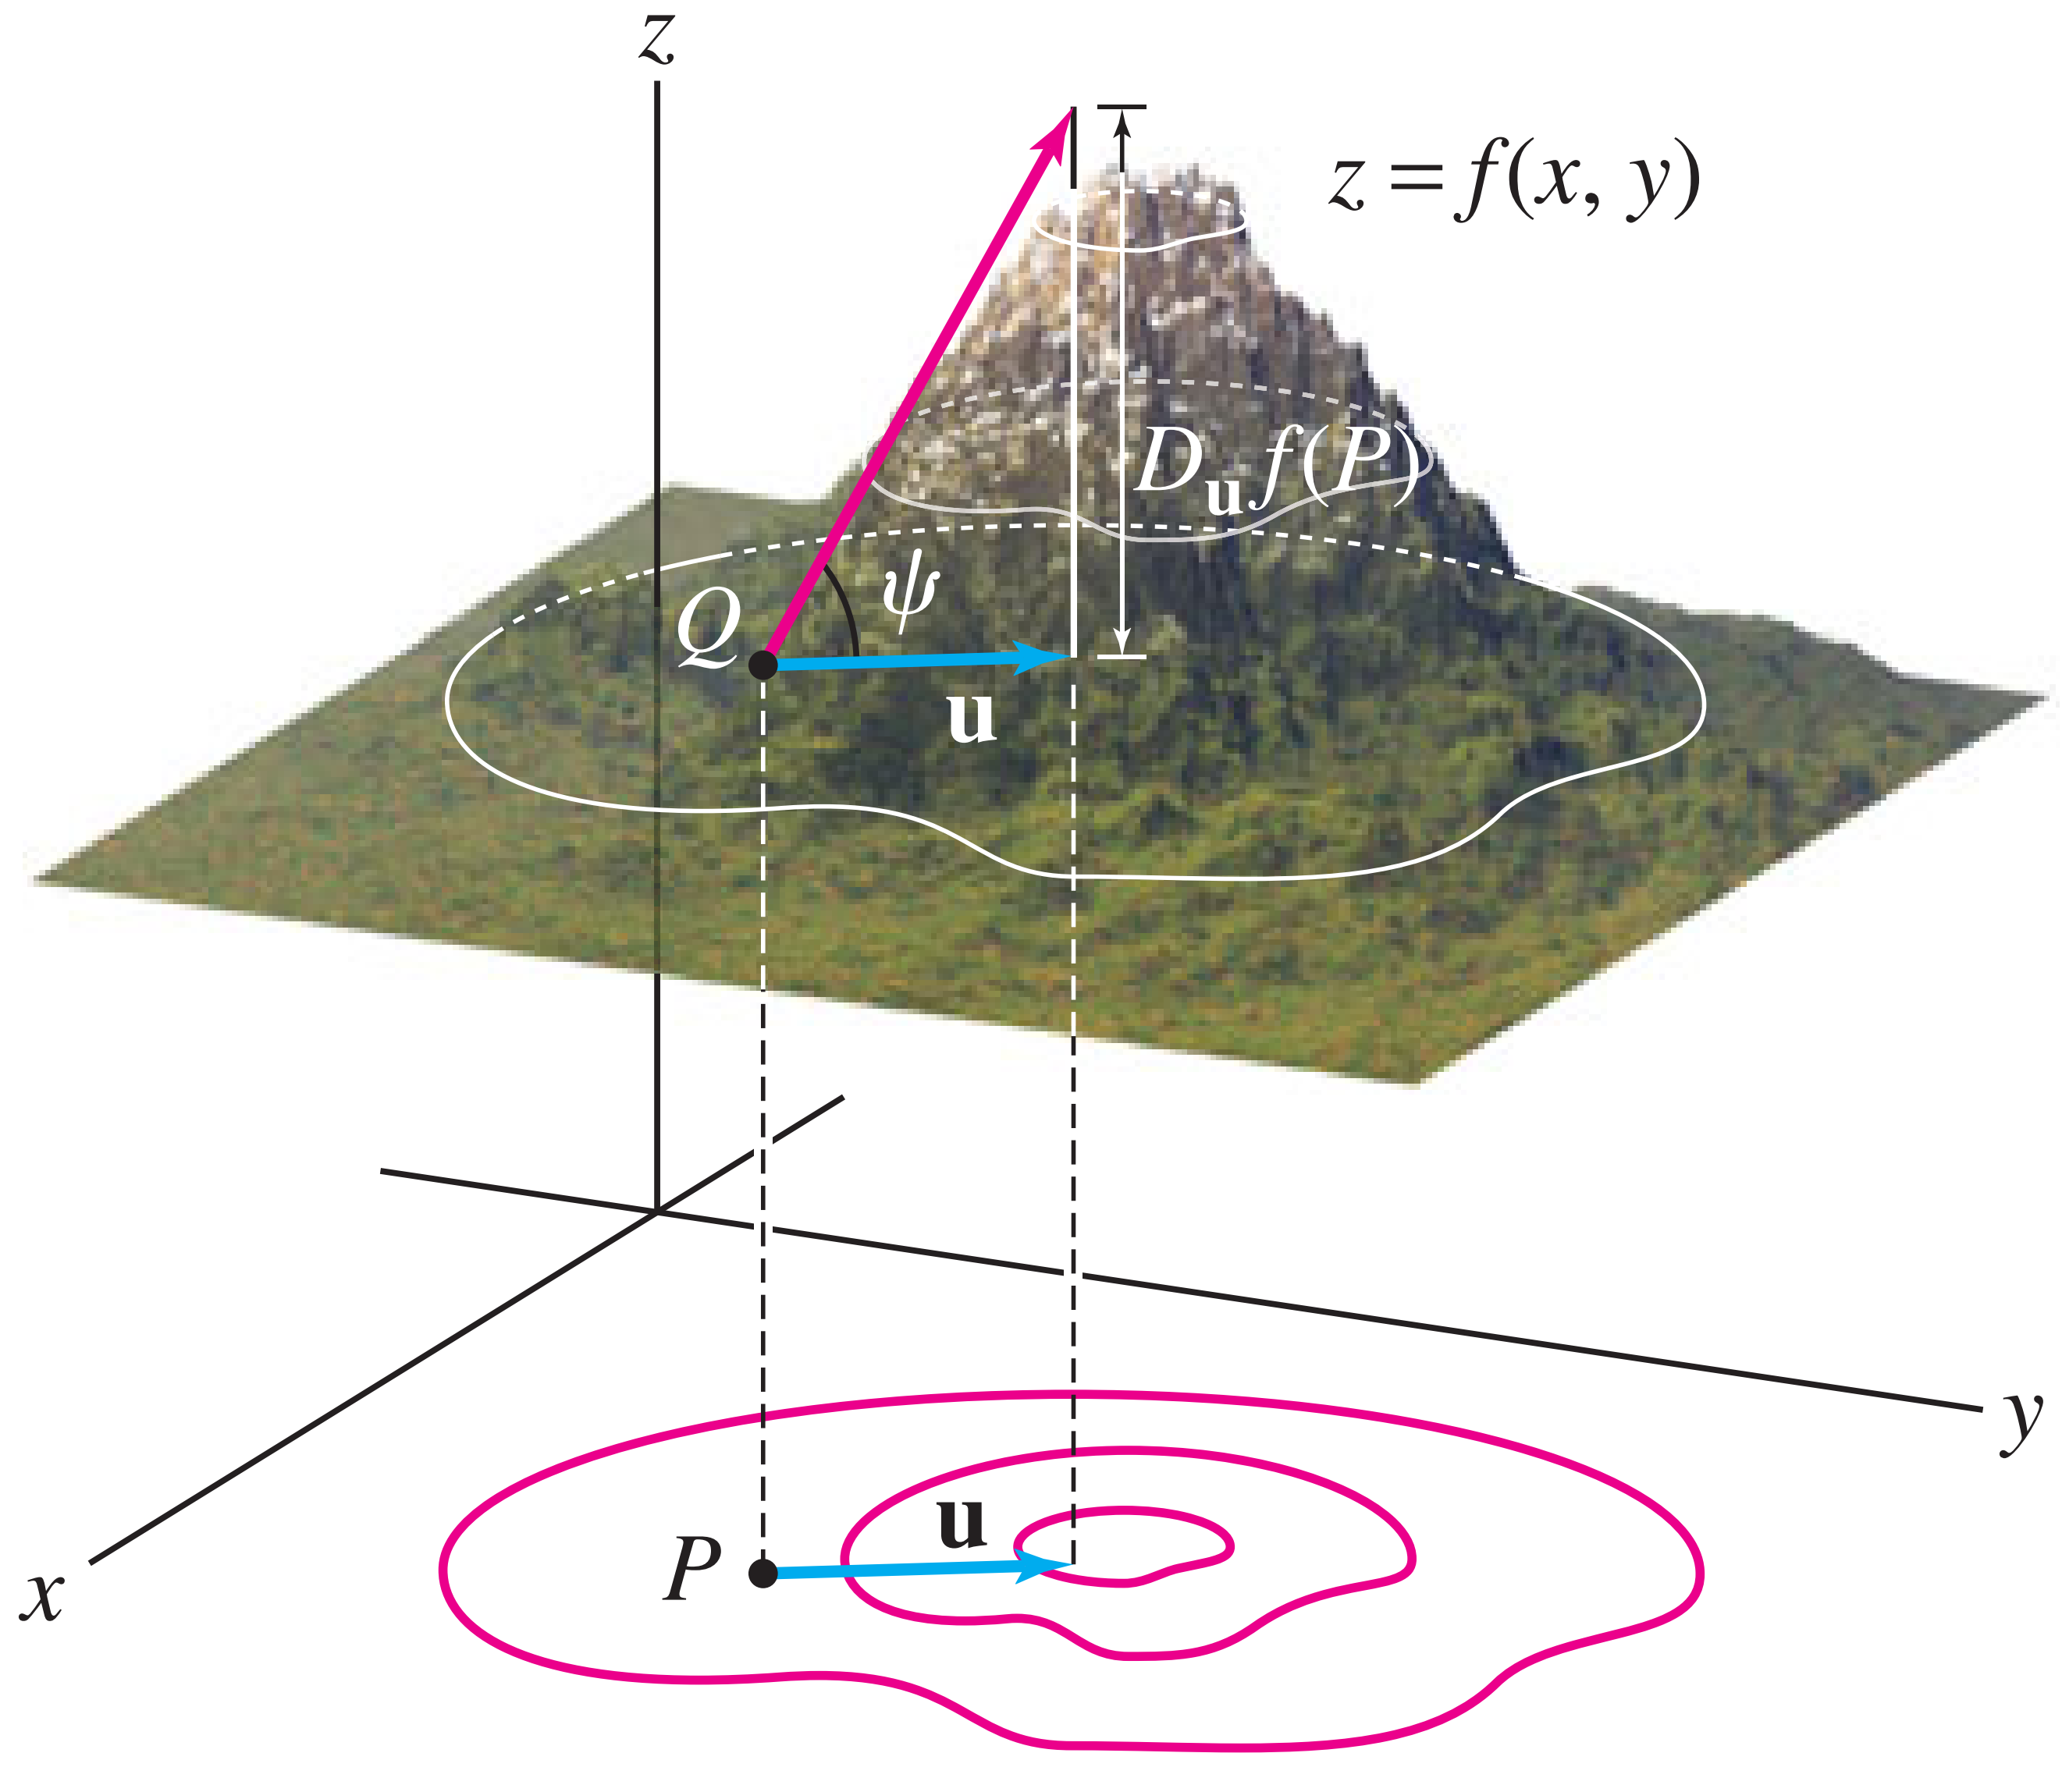
Fig. 2. The surface represented as a mountain. The directional derivative gives the slope angle in the direction , while the steepest ascent occurs in the direction of the gradient .
For in-text citations and the reference list, use the APA style (e.g., Author1 & Author2, 2021).
In in-text citations, include the author’s last name and the year of publication (Author, 2015). For direct quotes, the page number should also be provided, for example: “the construction of an artifact” (Fang & Widodo, 2019, p. 5).
When citing multiple sources at the same time, the references should be listed in alphabetical order (Canale, 2016; Kusumaningputri & Widodo, 2018).
For sources with up to three authors, list all authors (Author1, Author2, Author3, Author4, & Author5, 2021). For sources with more than three authors, list only the first author followed by “et al.” and the year of publication (Author1 et al., 2021).
The use of footnotes is not allowed and should not be used.
- Discussion
In the discussion, the researcher aims to strengthen the findings of their study by using the results of related research and compares those results with their own work. The similarities and differences of the findings are compared, analyzed, and interpreted in relation to previous studies.

- Conclusion
The conclusion section includes a summary and restatement of the main research findings. In this section, the most important points of the article, as well as the author’s perspective on the practical implications of the results, should be briefly presented. Explain how your research advances the relevant field compared to the current state of knowledge. Without a clear conclusion, reviewers and readers will find it difficult to assess the work and its suitability for publication in the journal.
Avoid repeating the abstract or merely listing the findings. Provide a clear scientific justification for your research and specify its potential applications and developments. You may also suggest future research and refer to ongoing studies.
Acknowledgements
In this section, if necessary, the authors express their gratitude to funding organizations or individuals who assisted in conducting the research, including those who directly contributed to advancing the study. For example, one could write: “We would like to thank ….” For instance:
The authors would like to thank the National Science Foundation (NSF) for funding this research. We also sincerely thank Dr. Wahidullah Jamal and Dr. Abdulhossein Soroush for providing valuable insights and guidance throughout the study. …

References
This section pertains to the list of references used in the article. Every source cited in the text must be included in the reference list, and conversely, all sources in the reference list must be cited in the text. The references used should be up-to-date.
The main sources of the article include journal articles, conference papers, research reports, theses, and dissertations that are accessible online (with a permanent link or DOI). At least 80% of the references should be journal articles as primary sources.
Each reference must be verified against the original source for accuracy, including the author’s name, year of publication, volume number, issue number, and permanent link/DOI. Published articles in the same journal can be used as a formatting example.
The reference list should be arranged alphabetically according to APA style and written in Times New Roman, font size 12, left-aligned, with single line spacing and a hanging indent as per the provided guidelines. Key points for hanging indent:
- The first line of each reference starts at the left margin.
- The second and subsequent lines are indented about 0.5 inches or 1.27 cm.
- Line spacing should be single, meaning each line of text is placed directly below the previous line without extra spacing.
Instructions for setting hanging indent in Word or Google Docs:
- Select all references.
- From the Paragraph menu, choose Special → Hanging.
See the example below.
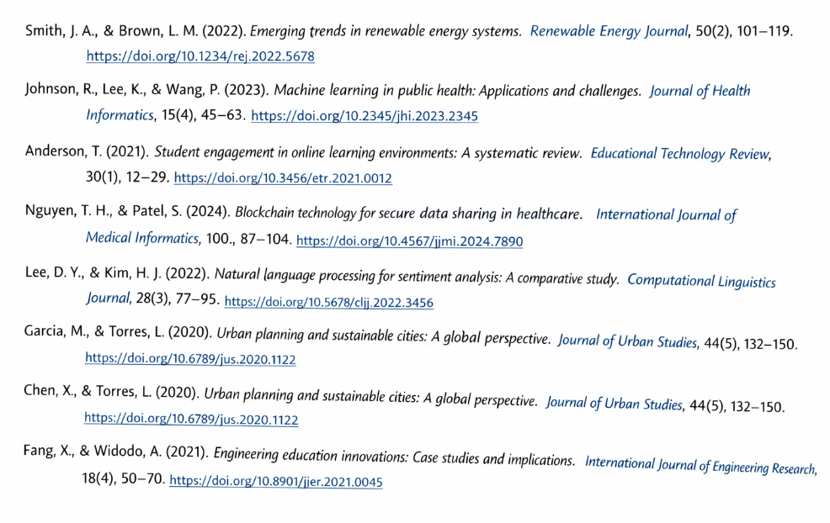

Vancouver referencing style

